**Activity 11.4 - Mohammed Abdin**

**Submission Instructions:**

Your submission for this assignment should be a Word document that includes the following screenshots, each labelled for the step that the screenshot represents:

Installing flask-swagger-ui

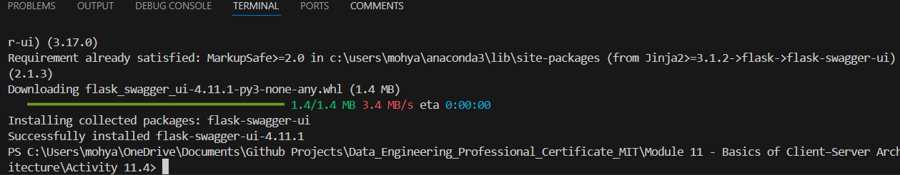

1. A screenshot of Visual Studio Code showing app.py from the Activity 11.4.zip file.

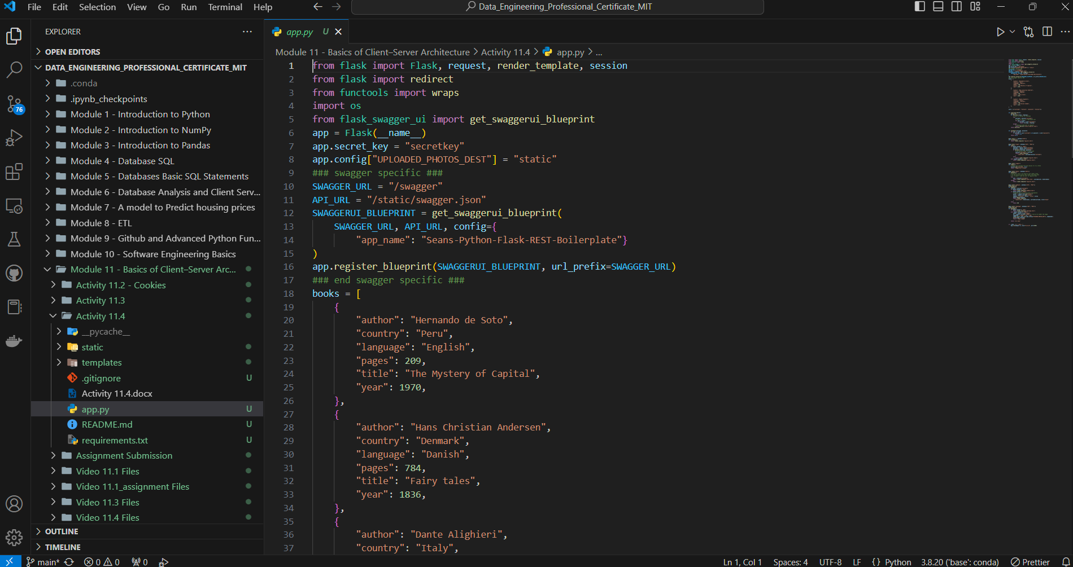

1. A screenshot of the web browser pointing to “<http://localhost:5000>” and showing the application running.

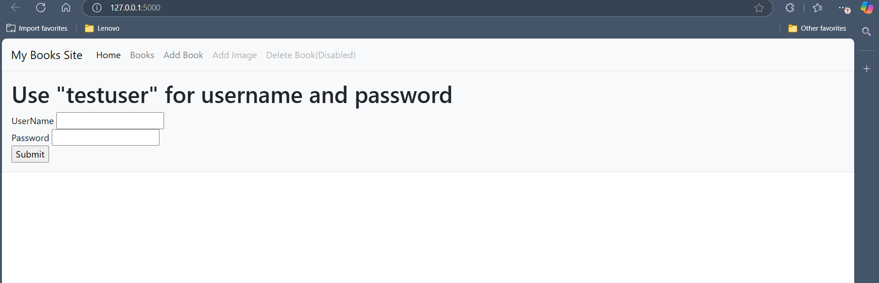

1. A screenshot of the browser pointing to <http://localhost:5000/swagger>.

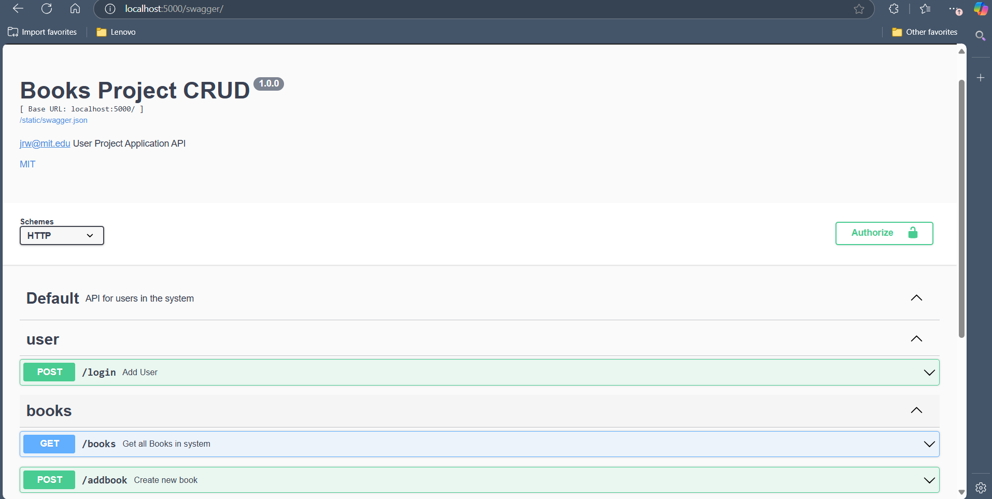

1. A screenshot of the call to GET *method* to get books, including output.
   1. Part 1:

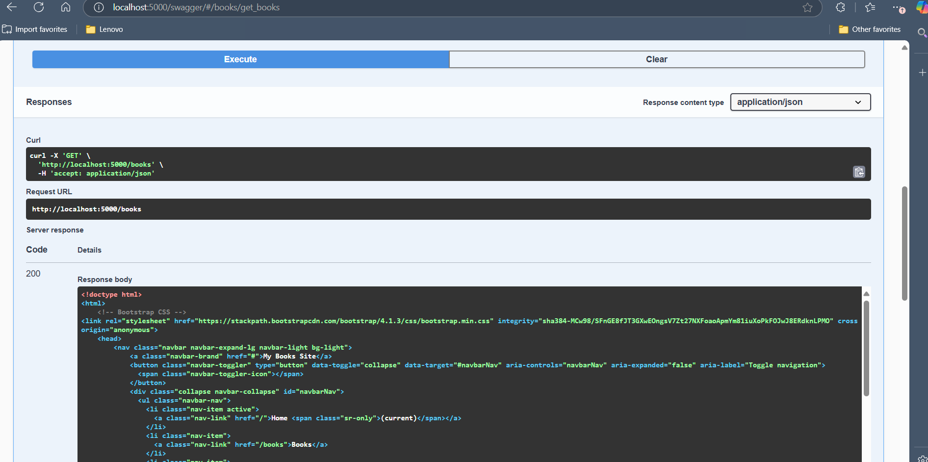

* 1. Part 2:

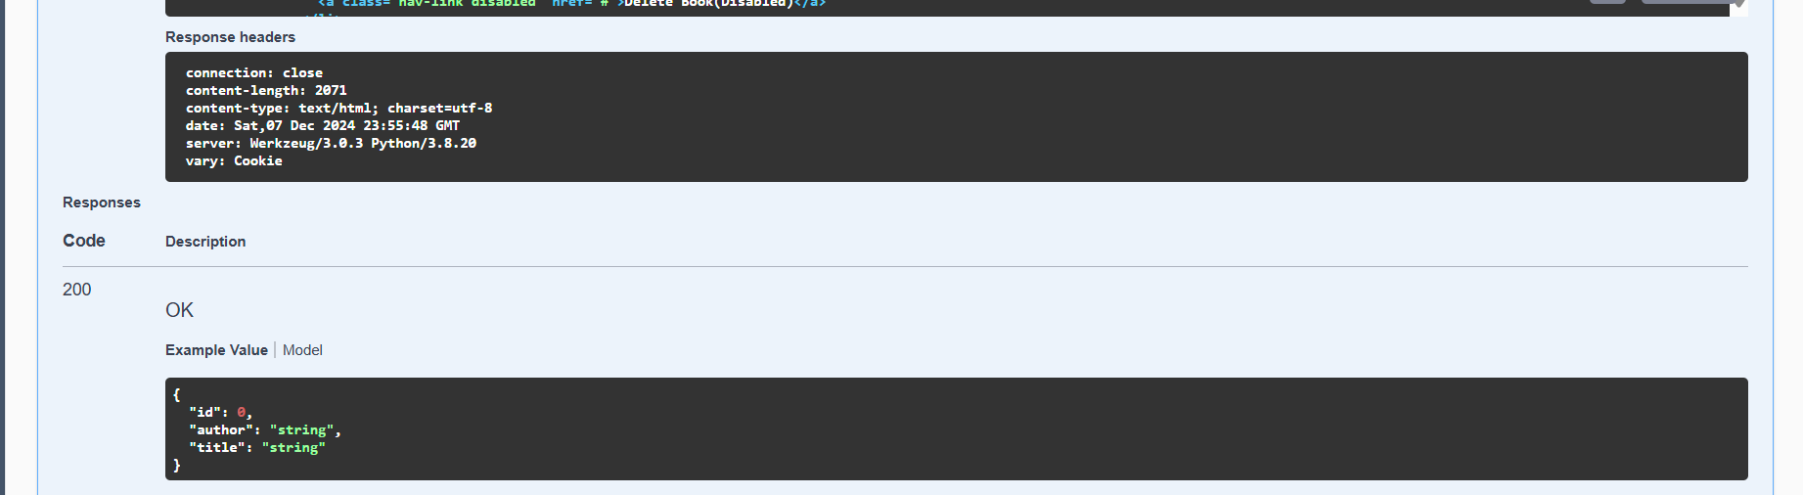

1. A screenshot of the call to POST *method* to create a book, including output.
   1. Adding a new book, author:

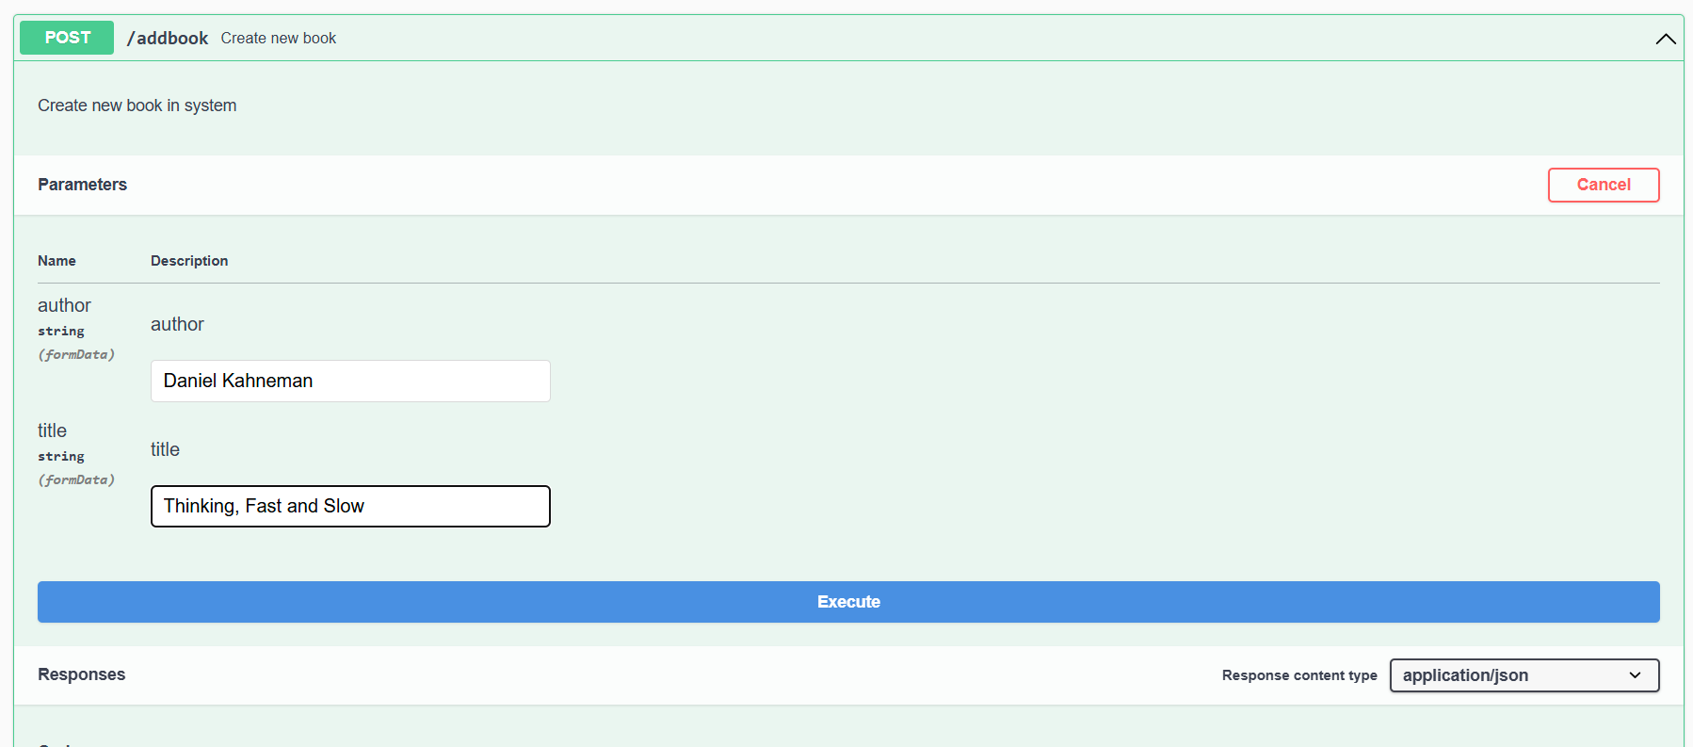

* 1. Response Pt1:

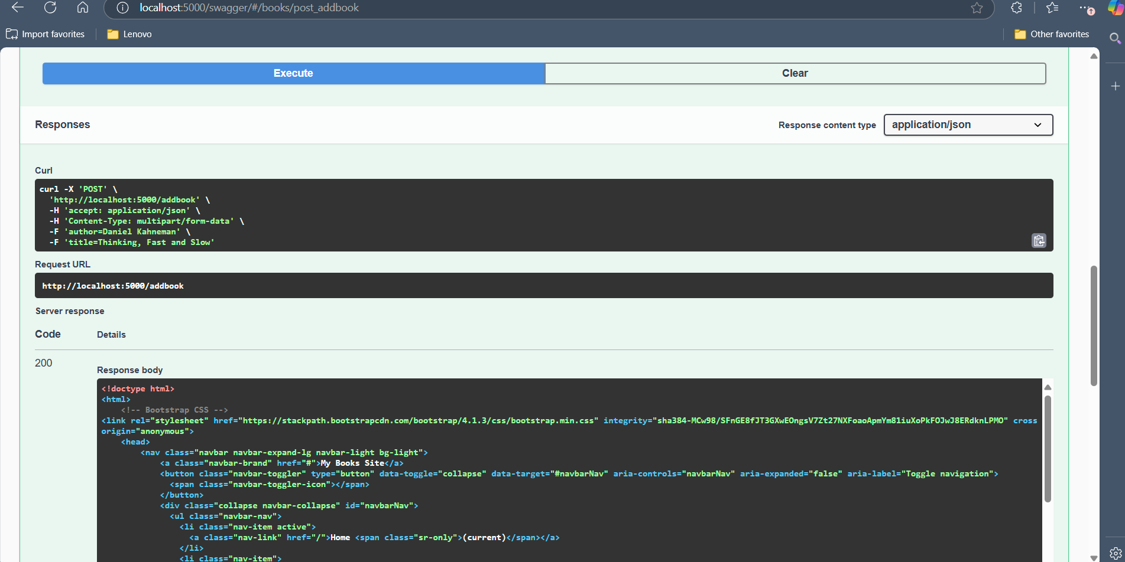

* 1. Response Pt2:

